**Python for data-sciences**

Table des matières

Module 4 - Working with Data in Python 2

Reading files with open 3

Writing files with open 9

Loading data with pandas 12

Working with and Saving data 19

Simple APIs Part 1 22

Simple APIs Part 2 33

Module 5 - Working with Numpy 42

Numpy 1D Arrays 42

Numpy 2D Arrays 54

Course Summary 64

Reference 66

# Module 4 - Working with Data in Python

Reading files with open

Writing files with open

Loading data with Pandas

Working with and Saving data with Pandas

# Reading files with open



In this section we will use Python’s built-in open function to create a file object and obtain the data from a txt file.

We will use Python’s open function to get a file object.



We can apply a method to that object to read data from the file.

We can open the file Example1 ". txt" as follows We use the open function.

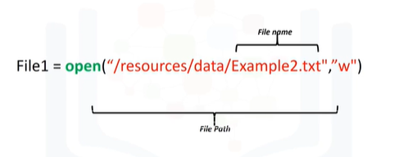

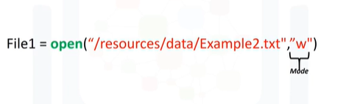

The first argument is the file path.

This is made up of the file name and the file directory.

The second parameter is the mode, common values used include 'r' for reading, 'w' for writing and 'a' for appending.

We will use ‘r’ for reading.

Finally, we have the file object.

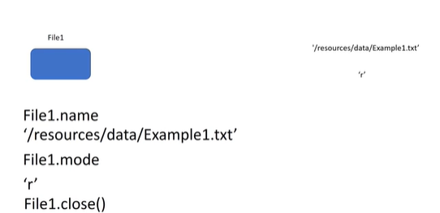

We can now use the file object to obtain information about the file.

We can use the data attribute name to get the name of the file.

The result is a string that contains the name of the file.

We can see what mode the object is in using the data attribute mode.

An ‘r’ is shown representing read.

You should always close the file object using the method close.

This may get tedious sometimes, so let’s use the “with statement.”

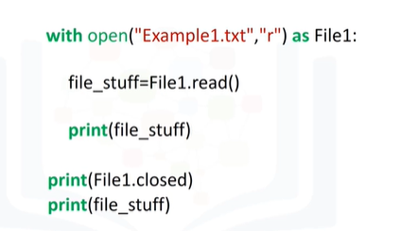

Using a 'with' statement to open the file is better practice because it automatically closes the file.

The code will run everything in the indent block, then closes the file.

This code reads the file Example1.txt, we can use the file object File 1.

The code will perform all operations in the indent block then close the file at the end of the indent.

The method read stores the values of the file in the variable file_stuff as a string.

You can print the file content.

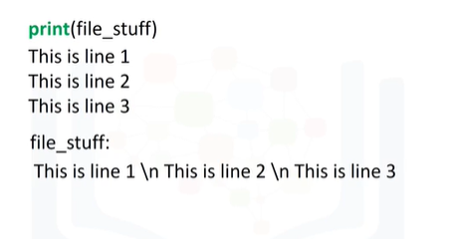

You can check if the file content is closed, but you cannot read from it outside the indent.

But you can print the file content outside the indent as well.

We can print the file content.

We will see the following.

When we examine the raw string, we will see the slash n, this is so Python knows to start a new line.

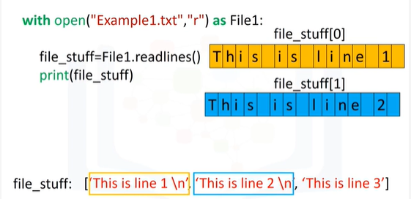

We can output every line as an element in a list using the method readlines.

The first line corresponds to the first element in the list.

The second line corresponds to the second element in the list, and so on.

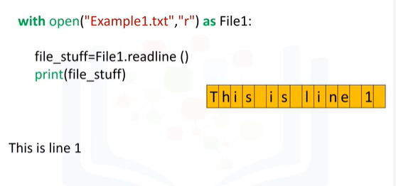We can use the method readline to read the first line of the file.

If we run this command, it will store the first line in the variable file_stuff, then print the first line.

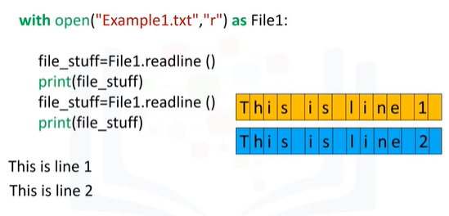

We can use the method read line twice: The first time it’s called, it will save the first line in the variable file_stuff and then print the first line.

The second time it’s called it will save the second line in the variable file_stuff and then print the second line.

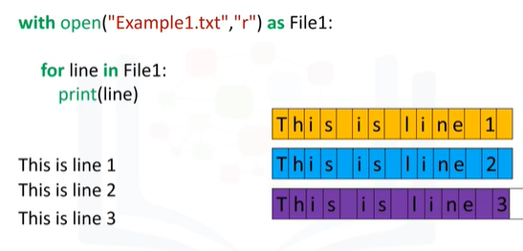

We can use a loop to print out each line individually as follows.

Let's represent every character in a string as a grid.

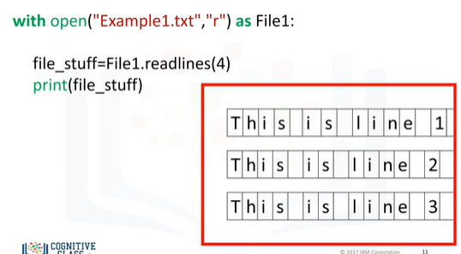

We can specify the number of characters we would like to read from a string as an argument to the method readlines.

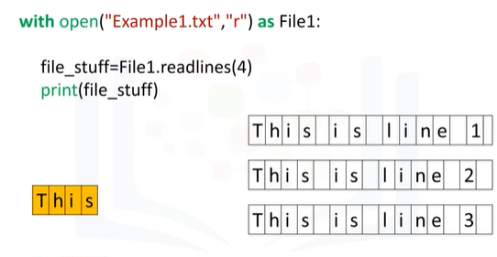

When we use a 4 as an argument in the method readlines, we print out the first four characters in the file.

Each time we call the method, we will progress through the text.

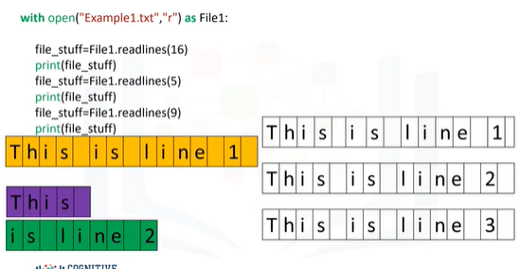

If we call the method with the argument 16, the first 16 characters are printed out and then the new line.

If we call the method a second time, the next five characters are printed out.

Finally, if we call the method the last time with the argument 9, the last 9 characters are printed out.

Check out the labs for more examples of methods and other file types.

# Writing files with open

We can also write to files using the open function.



We will use Python’s open function to get a file object, to create a text file, we can apply method write to write data to that file.

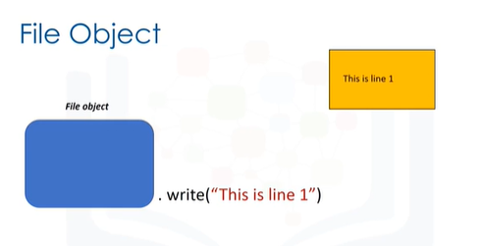

As a result, text will be written to the file.

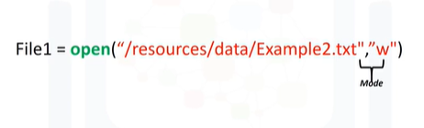

We can create the file Example2".txt" as follows: We use the open function.

The first argument is the file path.

This is made up of the file name, if you have that file in your directory, it will be over written, and the file directory.

We set the mode parameter to 'w' for writing.

Finally, we have the file object.

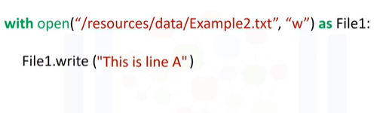

As before we use the "with" statement.

The code will run everything in the indent block, then close the file.

We create the file object File 1.

We use the open function.

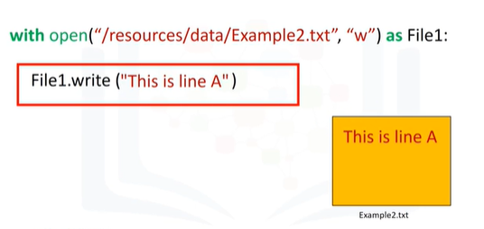

This creates a file Example2.txt in your directory.

We use the method write to write data into the file.

The argument is the text we would like input into the file.

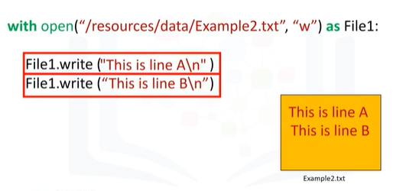

If we use the write method successively, each time it’s called, it will write to the file.

The first time it is called we will write: this is line A with a slash n to represent a new line.

The second time we call the method it will write: this is line b.

Then it will close the file.

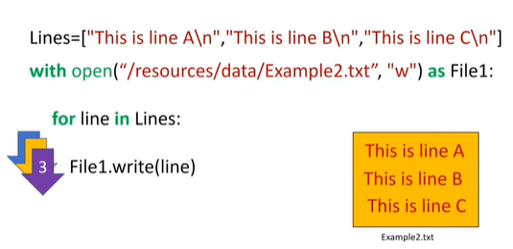

We can write each element in a list to a file.

As before we use a "with" command and the open function to create a file.

The list 'lines' has three elements consisting of text.

We use a “for loop” to read each element of the list lines and pass it to the variable line.

The first iteration of the loop writes the first element of the list to the file example 2.

The second iteration writes the second element of the list, and so on.

At the end of the loop the file will be closed.

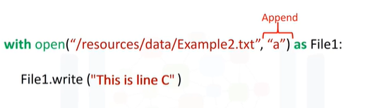

We can set the mode to appended using a lower case "a".

This will not create a new file, but just use the existing file.

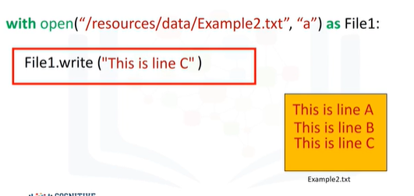

If we call the method write, it will just write to the existing file, then add: this is line C.

Then close the file.

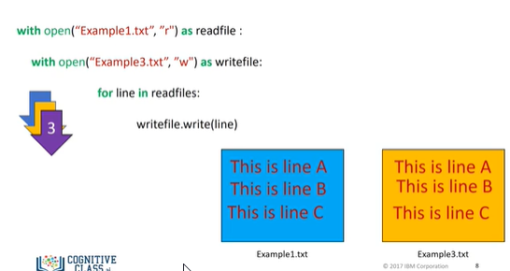

We can copy one file to a new file as follows: First, we read the file example 1 and interact with it via the file object "read file“.

Then we create a new file example 3 and use the file object "write file" to interact with it.

The “for loop” takes a line from the file object read file and stores it in the file example 3 using the file object write file.

The first iteration copies the first line.

The second iteration copies the second line till the end of the file is reached, then both files are closed.

Check out the labs for more examples.

# Loading data with pandas



Dependencies or libraries are pre-written code to help solve problems.

In this video, we will introduce pandas–a popular library for data analysis.

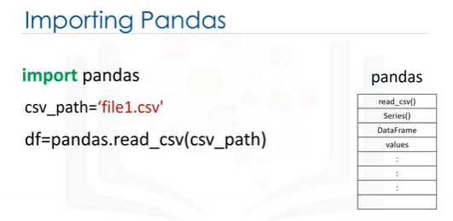

We can import the library or a dependency like pandas using the following command.

We start with the import command followed by the name of the library.

We now have access to a large number of pre-built classes and functions.

This assumes the library is installed.

In our lab environment, all the necessary libraries are installed.

Let’s say we would like to load a csv file using the pandas built-in function “read csv.”

A csv is a typical file type used to store data.

We simply type the word pandas, then a dot and the name of the function with all the inputs.

Typing pandas all the time may get tedious.

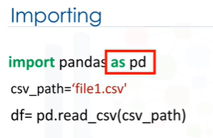

We can use the "as" statement to shorten the name of the library, in this case we use the standard abbreviation pd.

Now we type pd and a dot followed by the name of the function we would like to use, in this case, read_csv.

We are not limited to the abbreviation pd.

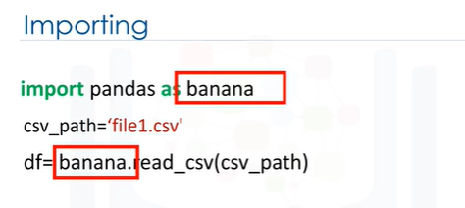

In this case, we use the term, banana.

We will stick with pd for the rest of this video.

Let’s examine this code more in-depth.

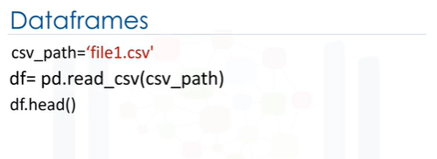

One way pandas allows you to work with data is with a data frame.

Let's go over the process to go from a csv file to a data frame.

This variable stores the path of the csv.

It is used as an argument to the read_csv function.

The result is stored to the variable df, this is short for “dataframe."

Now that we have the data in a dataframe, we can work with it.

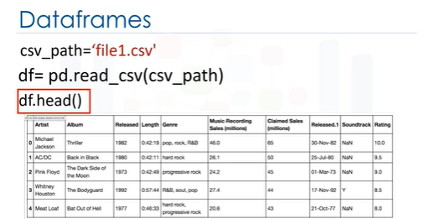

We can use the method head to examine the first 5 rows of a dataframe.

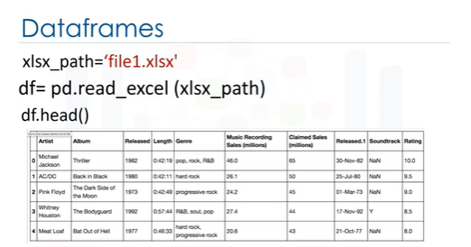

The process for loading an excel file is similar.

We use the path of the excel file.

The function reads excel.

The result is a dataframe.

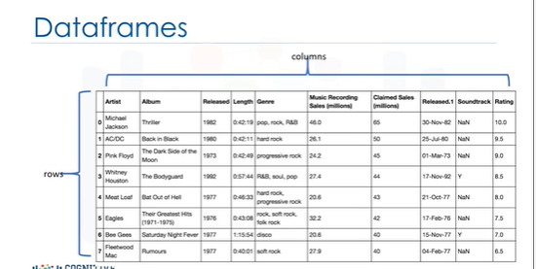

A dataframe is comprised of rows and columns.

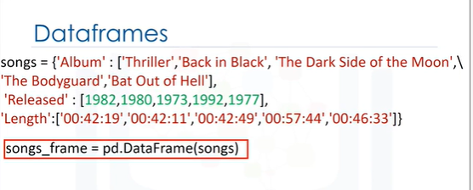

We can create a data frame out of a dictionary.

The keys correspond to the column labels.

The values are lists corresponding to the rows.

We then cast the dictionary to a dataframe using the function DataFrame.

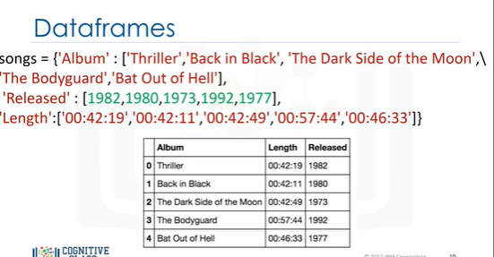

We can see the direct correspondence between the table.

The keys correspond to the table headers.

The values are lists corresponding to the rows.

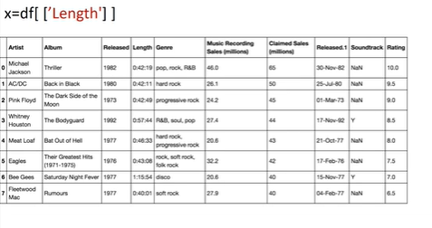

We can create a new dataframe consisting of one column.

We just put the dataframe name, in this case "df" and the name of the column header enclosed in double brackets.

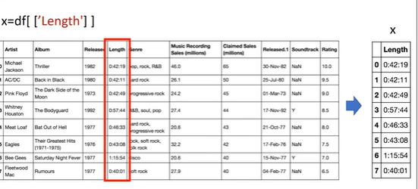

The result is a new dataframe comprised of the original column.

You can do the same thing for multiple columns.

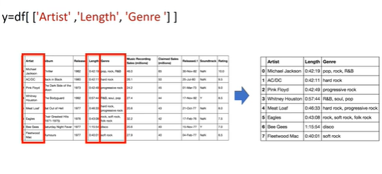

We just put the dataframe name, in this case "df" and the name of the multiple column headers enclosed in double brackets.

The result is a new dataframe comprised of the specified columns.

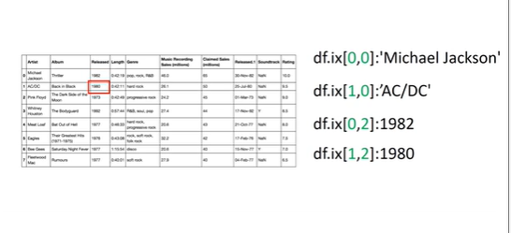

One way to access unique elements is the ix method.

You can access the 1st row and first column as follows.

You can access the 2nd row and first column as follows.

You can access the 1st row,3rd column as follows.

You can access the 2nd row, 3rd column as follows.

You can use the name of the column as well.

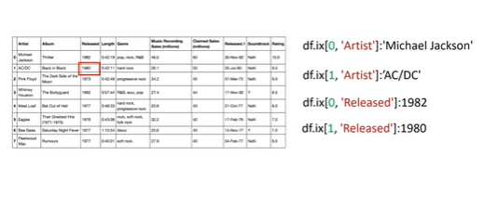

You can access the 1st row of the column named 'Artist’ as follows.

Similarly, you can access the 2nd row of the column named ‘Artist.’

You can access the 1st row of the column named 'Released’ as follows.

Finally, you can access the 2nd row of the column named 'Released.’

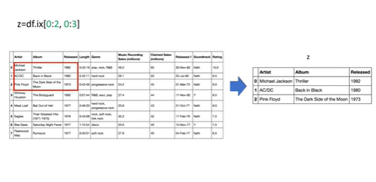

You can also slice dataframes and assign the values to a new dataframe.

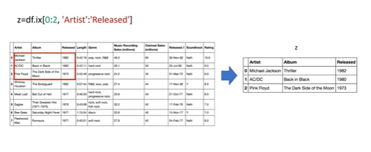

We assign the first two rows and the first three columns to the variable z.

The result is a dataframe comprised of the selected rows and columns.

You can also slice dataframes and assign the values to a new dataframe using the column names.

The code assigns the first three rows and all columns in-between to the columns named 'Artist’ and 'Released.’

The result is a new dataframe z with the corresponding values.

# Working with and Saving data



When we have a dataframe we can work with the data and save the results in other formats.



Consider the stack of 13 blocks of different colors.

We can see there are three unique colors.

Let’s say you would like to find out how many unique elements are in a column of a dataframe.

This may be much more difficult because instead of 13 elements you may have millions.

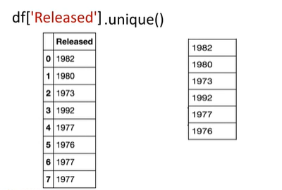

pandas has the method unique to determine the unique elements in a column of a dataframe.

Let’s say we would like to determine the unique year of the albums in the data set.

We enter the name of the dataframe, then enter the name of the column ‘Released’ within brackets.

Then we apply the method unique.

The result is all of the unique elements in the column ‘Released.’

Let's say we would like to create a new database consisting of songs from the 1980's and after.

We can look at the column ‘Released’ for songs made after 1979, then select the corresponding columns.

We can accomplish this within one line of code in Pandas, but let’s break up the steps.

We can use the inequality operators for the entire dataframe in pandas.

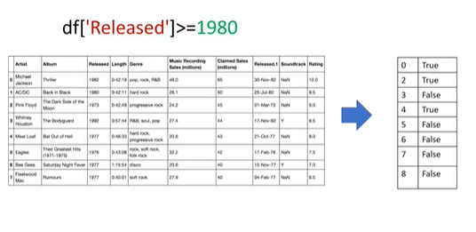

The result is a series of Boolean values.

For our case, we simply specify the column ‘Released’ and the inequality for the albums after 1979.

The result is a series of Boolean values.

The result is true when the condition is true and false otherwise.

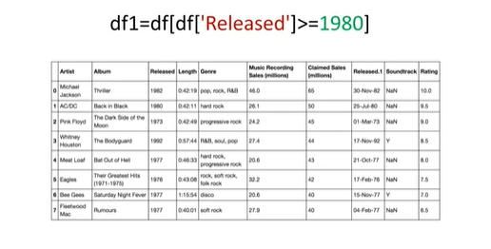

We can select the specified columns in one line; we simply use the dataframe’s names, and in square brackets we place the previously mentioned inequality and assign it to the variable df1.

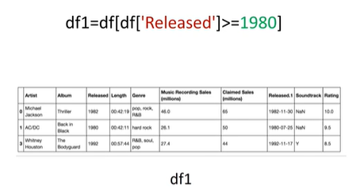

We now have a new dataframe, where each album was released after 1979.

We can save the new dataframe using the method to_csv.

The argument is the name of the csv file.



Make sure you include a dot csv extension.

There are other functions to save the dataframe in other formats.

# Simple APIs Part 1





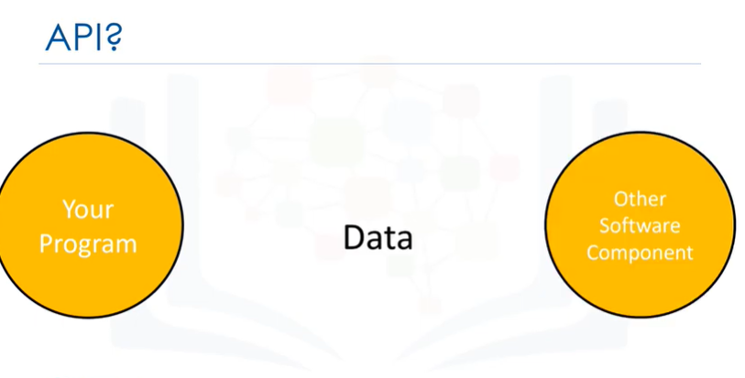

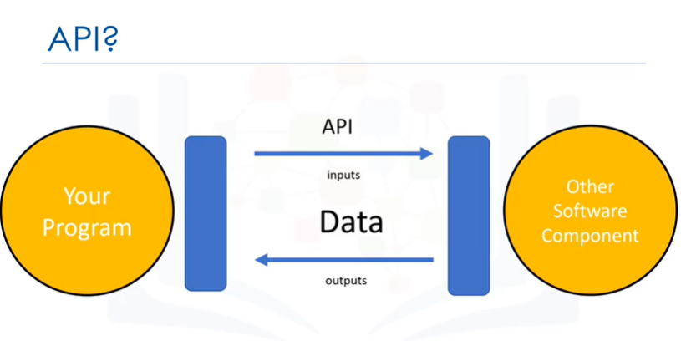

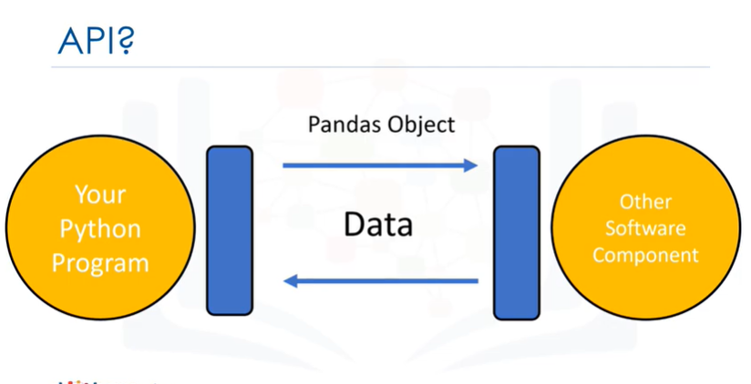

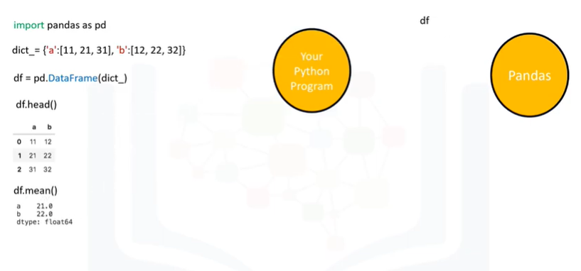



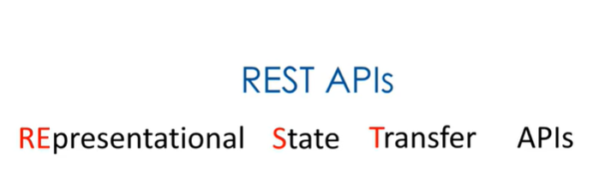





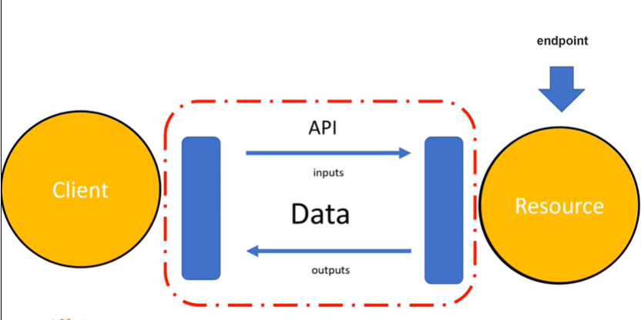



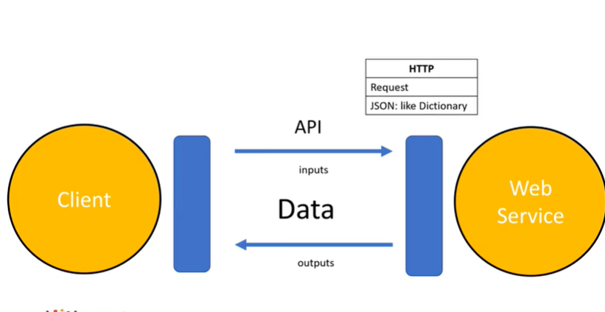

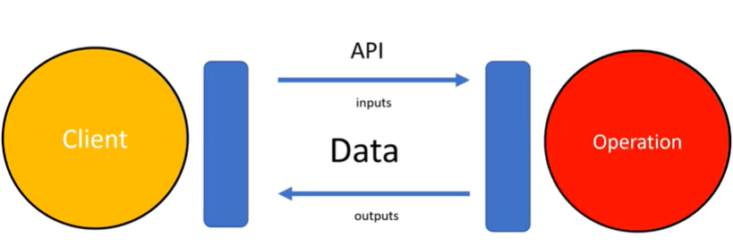

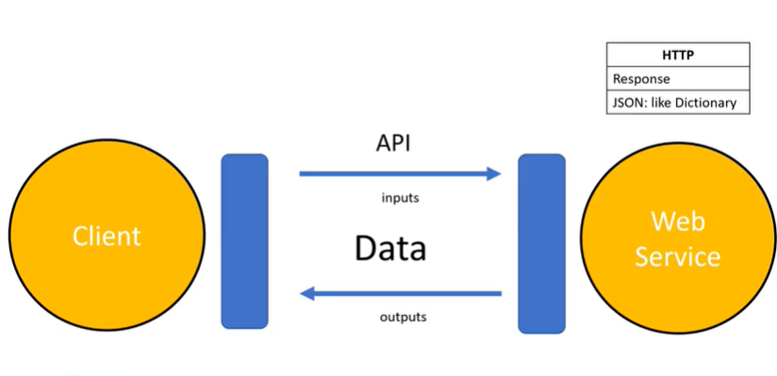

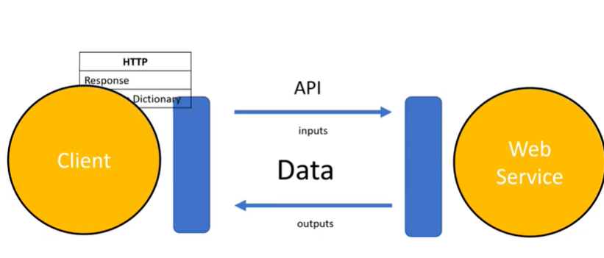



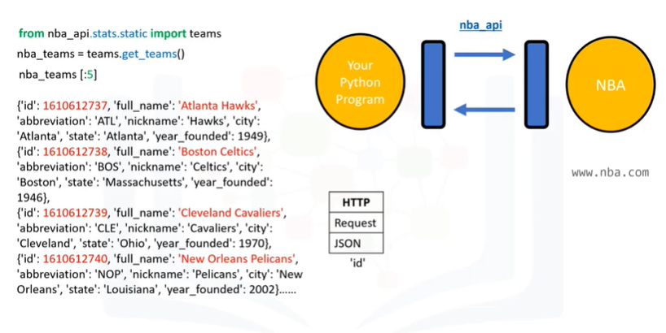

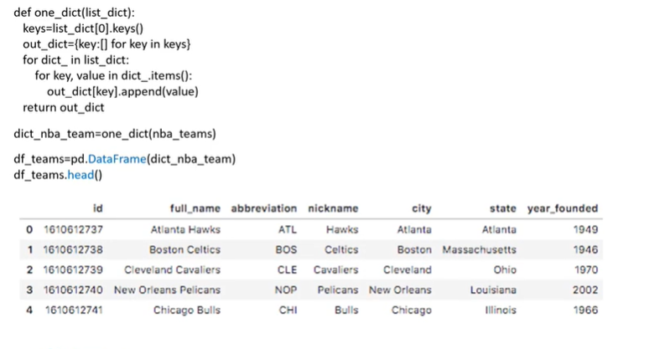

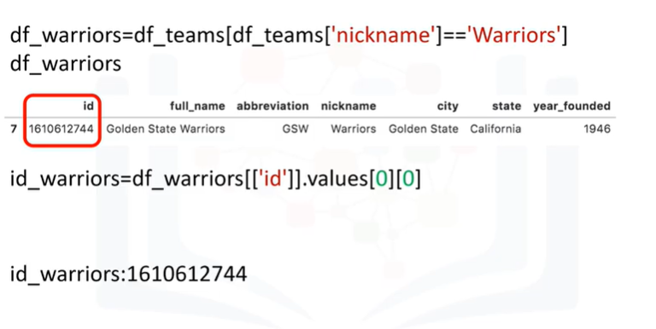









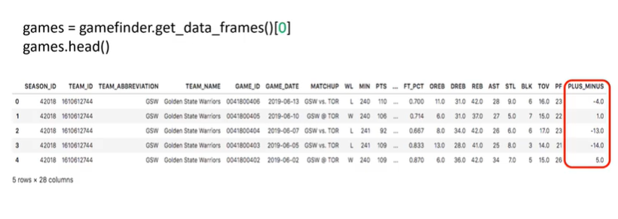

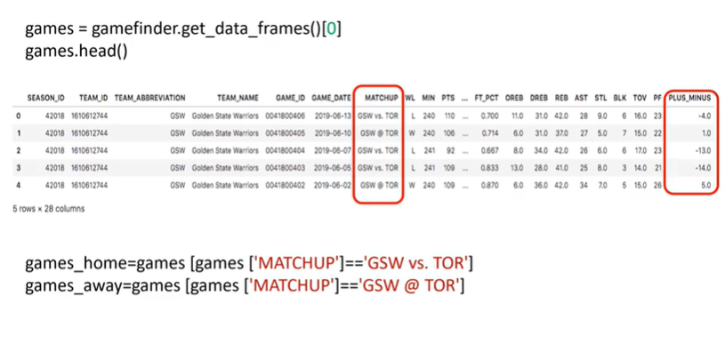

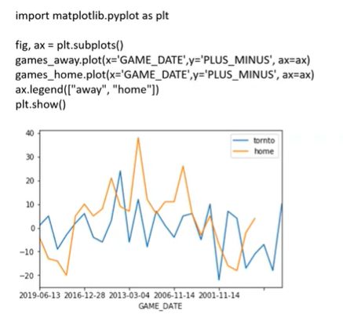

# Simple APIs Part 2



















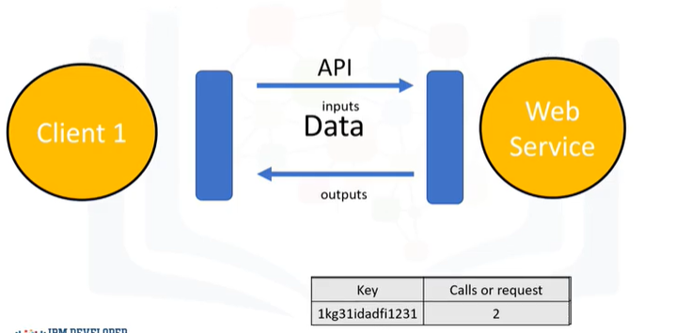

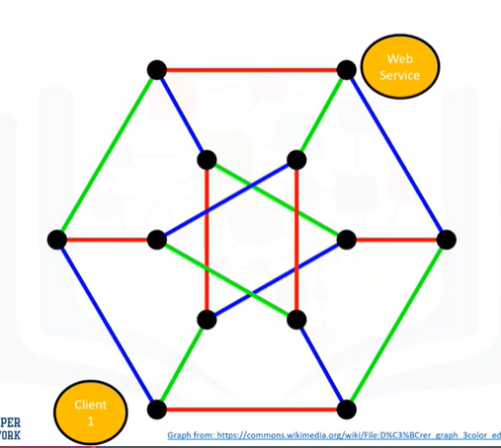



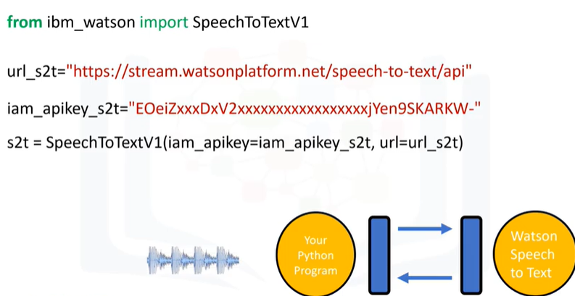

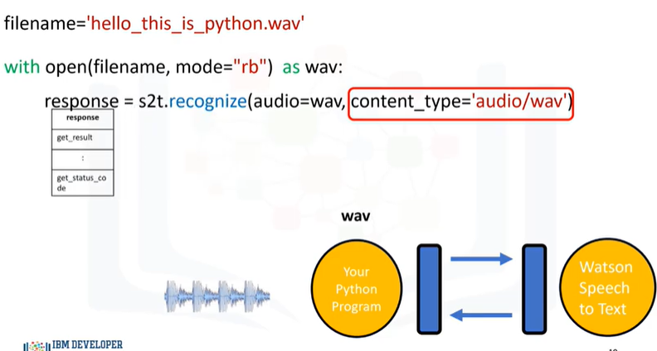

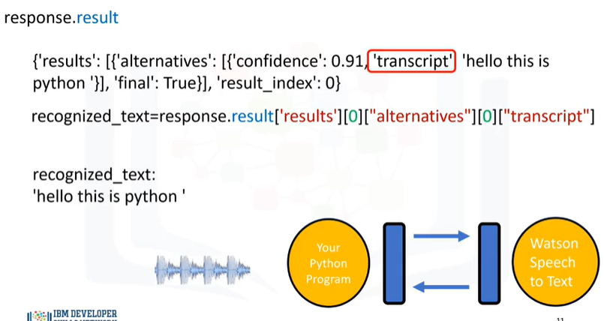



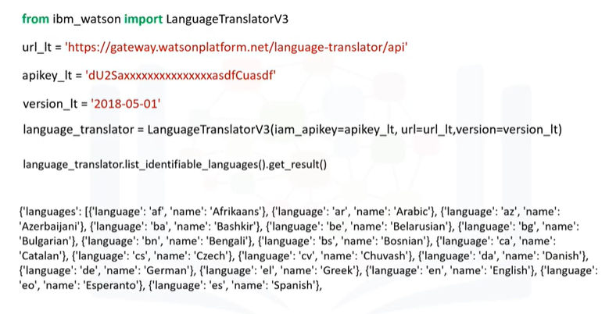

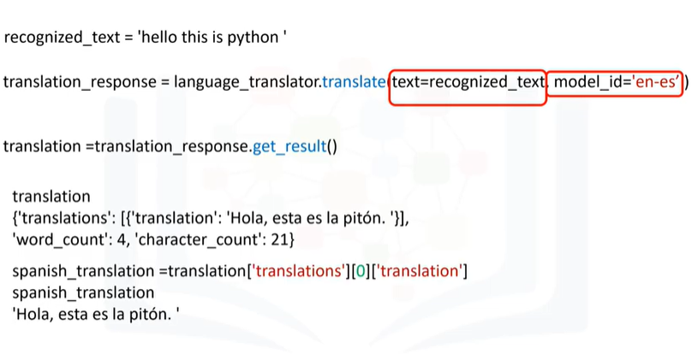

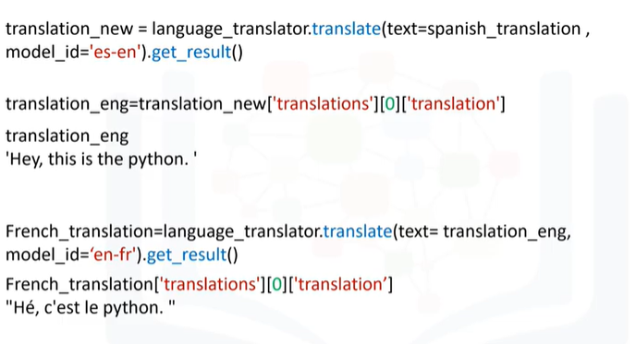

# [Module 5 - Working with Numpy](https://courses.cognitiveclass.ai/courses/course-v1:Cognitiveclass+PY0101EN+v2/course/#block-v1:Cognitiveclass+PY0101EN+v2+type@chapter+block@d553529b805a412788250291204686ee)

# Numpy 1D Arrays



In this video, we will be covering Numpy in 1D, in particular "n d arrays".

Numpy is a library for scientific computing.

It has many useful functions.

There are many other advantages like speed an memory.

Numpy is also the basis for pandas, so check out our pandas video.

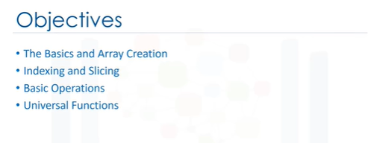

In this video we will be covering: 1) The Basics and Array Creation 2) Indexing and Slicing 3) Basic Operations 4) Universal Functions.



Let's go over how to create a numpy array.

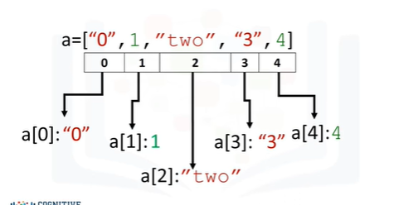

A Python list is a container that allows you to store and access data.

Each element is associated with an index.

We can access each element using a square bracket, as follows.

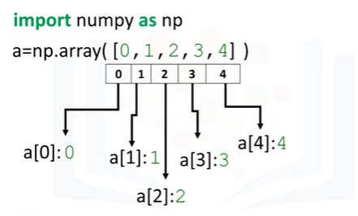

A "numpy" array or "ndarray" is similar to a list.

It's usually fixed in size and each element is of the same type, in this case, integers.

We can cast a list to a numpy array by first importing numpy.

We then cast the list as follows.

We can access the data via an index.

As with a list, we can access each element with an integer and a square bracket.

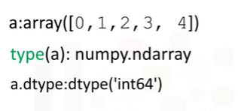

The value of 'a' is stored as follows.

If we check the type of the array we get "numpy.ndarray".

As numpy arrays contain data of the same type, we can use the attribute "dtype" to obtain the data-type of the array’s elements.

In this case a 64-bit integer.

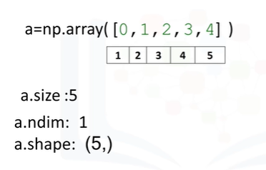

Let's review some basic array attributes using the array 'a'.

The attribute size is the number of elements in the array.

As there are 5 elements, the result is 5.

The next two attributes will make more sense when we get to higher dimensions, but let's review them.

The attribute "ndim” represents the number of array dimensions or the rank of the array, in this case one.

The attribute "shape” is a tuple of integers indicating the size of the array in each dimension.

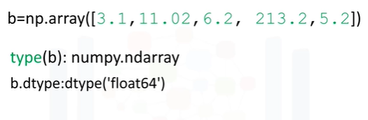

We can create a numpy array with real numbers.

When we check the type of the array, we get numpy.ndarray.

If we examine the attribute "dtype," we see float 64 as the elements are not integers.

There are many other attributes.

Check out "numpy.org”.



Let's review some Indexing and Slicing methods.

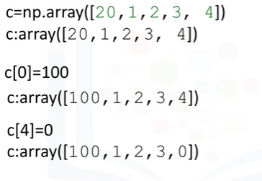

We can change the first element of the array to 100, as follows.

The arrays first value is now 100.

We can change the 5-th element of the array as follows.

The fifth element is now 0.

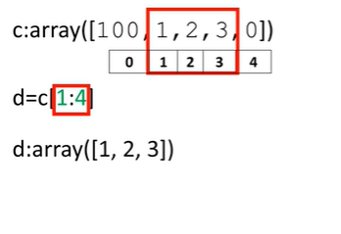

Like lists and tuples, we can slice a numpy array.

The elements of the array correspond to the following index.

We can select the elements from 1 to 3 and assign it to a new numpy array 'd' as follows.

The elements in 'd' correspond to the index.

Like lists, we do not count the element corresponding to the last index.

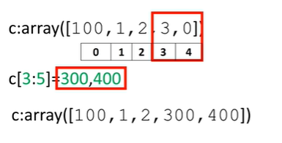

We can assign the corresponding indexes to new values as follows.

The array 'c' now has new values.

See the labs or numpy.org for more examples of what you can do with numpy.



Numpy makes it easier to do many operations that are commonly performed in data science.

These same operations are usually computationally faster and require less memory in numpy compared to regular Python.

Let's review some of these operations on 1 dimensional arrays.

We will look at many of the operations in the context of Euclidian vectors to make things more interesting.

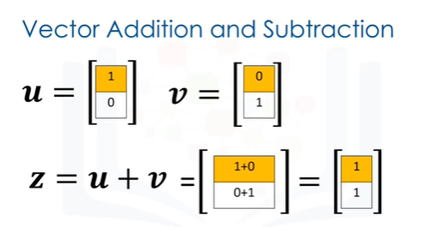

Vector addition is a widely used operation in data science.

Consider the vector 'u' with two elements; the elements are distinguished by the different colors.

Similarly, consider the vector 'v' with two components.

In vector addition, we create a new vector in this case 'z'.

The first component of 'z' is the addition of the first component of vectors 'u' and 'v'.

Similarly, the second component is the sum of the second components of 'u' and 'v'.

This new vector 'z' is now a linear combination of the vector 'u' and 'v'.

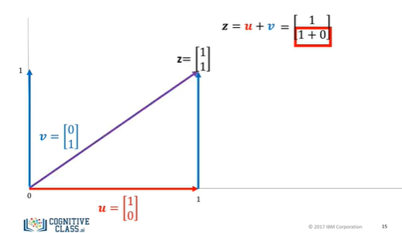

Representing vector addition with line segment or arrows is helpful.

The first vector is represented in red; the vector will point in the direction of the two components.

The first component of the vector is one; as a result, the arrow is offset one unit from the origin in the horizontal direction.

The second component is 0.

We represent this component in the vertical direction, as this component is zero the vector does not point in the horizontal direction.

We represent the second vector in blue.

The first component is zero, therefore, the arrow does not point in the horizontal direction.

The second component is one.

As a result, the vector points in the vertical direction one unit.

When we add the vector 'u' and 'v' we get the new vector 'z'.

We add the first component, this corresponds to the horizontal direction.

We also add the second component.

It's helpful to use the tip-to-tail method when adding vectors, placing the tail of vector 'v' on the tip of vector 'u'.

The new vector 'z' is constructed by connecting the base of the first vector 'u' with the tail of the second 'v'.

The following 3 lines of code will add the two lists and place the result in the list 'z'.

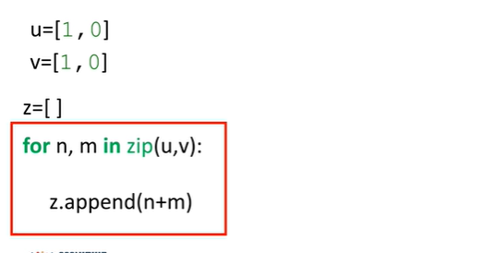

We can also perform vector addition with one line of numpy code.

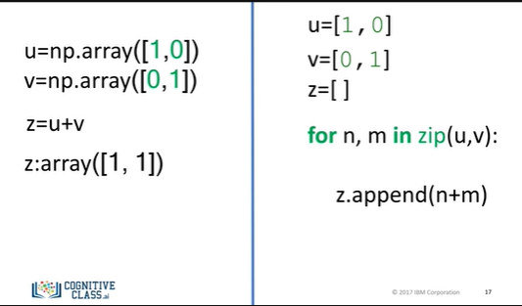

It would require multiple lines to perform vector subtraction on two lists, as shown on the right side of the screen.

In addition, the numpy code will run much faster.

This is important if you have lots of data.

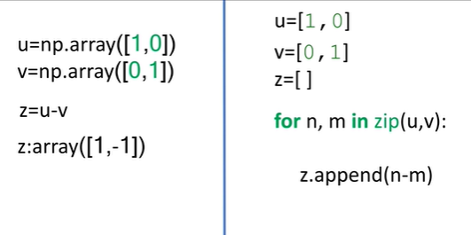

We can also perform vector subtraction by changing the addition sign to a subtraction sign.

It would require multiple lines to perform vector subtraction on two lists, as shown on the right side of the screen.

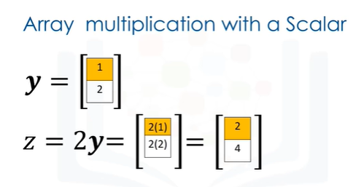

Vector multiplication with a Scalar is another commonly performed operation.

Consider the vector 'y', each component is specified by a different color.

We simply multiply the vector by a scaler value, in this case, 2.

Each component of the vector is multiplied by 2; in this case, each component is doubled.

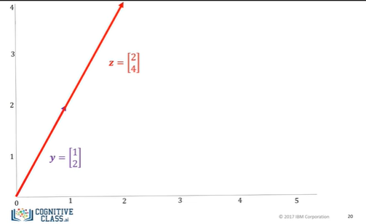

We can use the line segment or arrows to visualize what’s going on.

The original vector y is in purple.

After multiplying it by a scalar value of 2, the vector is stretched out by two units, as shown in red.

The new vector is twice as long in each direction.

Vector multiplication with a scalar only requires one line of code using Numpy.

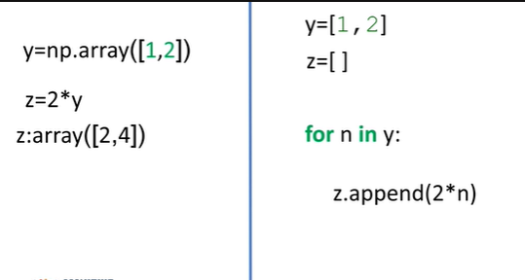

It would require multiple lines to perform the same task as shown with python lists, as shown on the right side of the screen.

In addition, the operation would also be much slower.

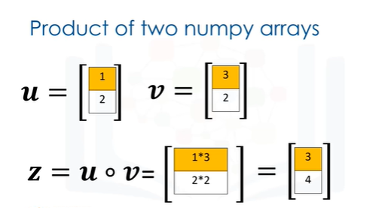

Hadamard product is another widely used operation in data science.

Consider the following two vectors 'u' and 'v'.

The Hadamard product of 'u' and 'v' is a new vector 'z'.

The first component of 'z' is the product of the first element of 'u' and 'v'.

Similarly, the second component is the product of the second element of 'u' and 'v'.

The resultant vector consists of the entrywise product of 'u' and 'v'.

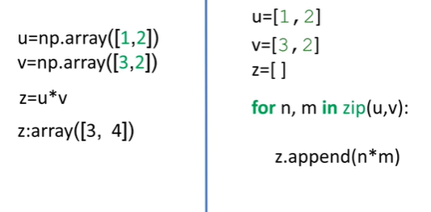

We can also perform Hadamard product with 1 line of code in Numpy.

It would require multiple lines to perform Hadamard product on two lists as shown on the right side of the screen.

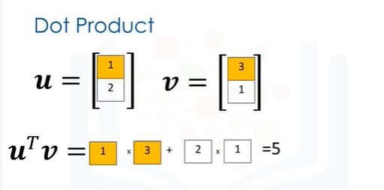

The dot product is another widely used operation in data science, consider the vector 'u' and 'v'.

The dot product is a single number given by the following term and represents how similar two vectors are.

We multiply the first component from 'v' and 'u'.

We then multiply the second component and add the result together.

The result is a number that represents how similar the two vectors are.

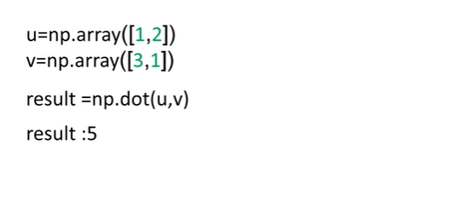

We can also perform dot product using the numpy function "dot” and assign it the variable "result” as follows.

Consider the array 'u'.

The array contains the following elements.

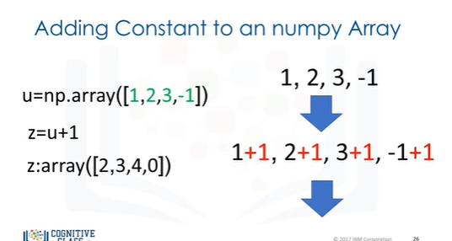

If we add a scalar value to the array, numpy will add that value to each element.

This property is known as broadcasting.



A universal function is a function that operates on ndarrays.

We can apply a universal function to a Numpy array.

Consider the arrays 'a'.

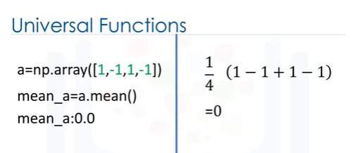

We can calculate the mean or average value of all the elements in 'a' using the method "mean”.

This corresponds to the average of all the elements.

In this case the result is zero.

There are many other functions, for example, consider the numpy arrays 'b'.

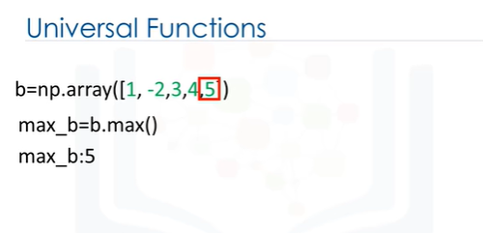

We can find the maximum value using the method 5.

We see the largest value is 5.

Therefore, the method max returns a 5.

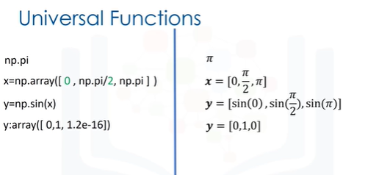

We can use numpy to create functions that map numpy arrays to new numpy arrays.

Let's implement some code on the left side of the screen and use the right side of the screen to demonstrate what's going on.

We can access the value of pi in Numpy as follows.

We can create the following numpy array in Radians.

This array corresponds to the following vector.

We can apply the function "sine" to the array x and assign the values to the array y; this applies the sine function to each element in the array.

This corresponds to applying the sine function to each component of the vector.

The result is a new array y where each value corresponds to a sine function being applied to each element in the array x.

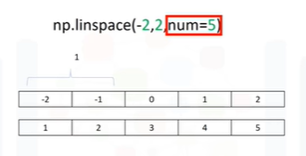

A useful function for plotting mathematical functions is "linespace".

Linespace returns evenly spaced numbers over a specified interval.

We specify the starting point of the sequence.

The ending point of the sequence.

The parameter "num" indicates the Number of samples to generate, in this case, 5.

The space between samples is 1.

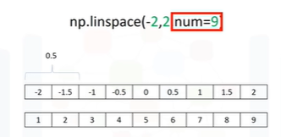

If we change the parameter num to 9, we get 9 evenly spaced numbers over the interval from -2 to 2.

The result is the difference between subsequent samples is 0.5 as opposed to one as before.

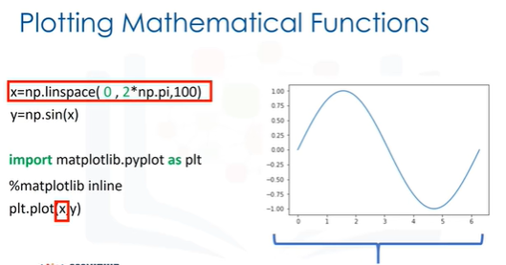

We can use the function linespace to generate 100 evenly spaced samples from the interval 0 to 2 pi.

We can use the Numpy function sine to map the array x to a new array y.

We can import the library pyplot as plt to help us plot the function.

As we are using a Jupyter notebook, we use the command "matplotlib inline" to display the plot.

The following command plots a graph.

The first input corresponds to the values for the horizontal or x-axis.

The second input corresponds to the values for the vertical or y-axis.

There is a lot more you can do with Numpy.

Check out the labs and numpy.org for more.

Thanks for watching this video.

# Numpy 2D Arrays



We can create Numpy arrays with more than one dimension.

This section will focus only on 2D arrays, but you can use Numpy to build arrays of much higher dimensions.

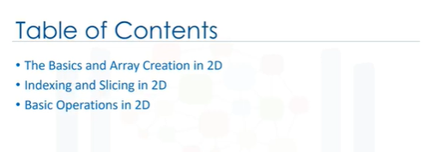

In this video we will cover the basics and array creation in 2D, indexing and slicing in 2D, and basic operations in 2D.

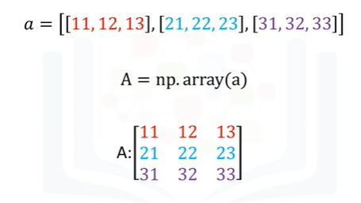

Consider the list "a".

The list contains three nested lists each of equal size.

Each list is color coded for simplicity.

We can cast the list to a numpy array as follows.

It is helpful to visualize the Numpy array as a rectangular array, each nested list corresponds to a different row of the matrix.

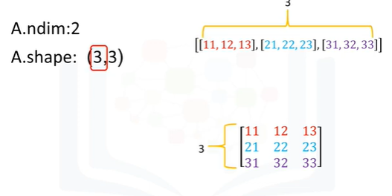

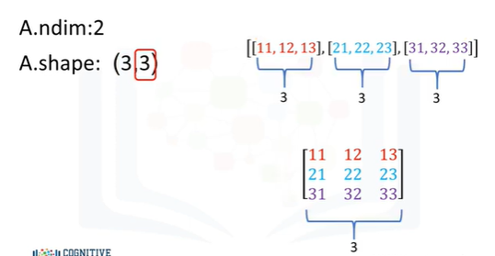

We can use the attribute "ndim" to obtain the number of axes or dimensions referred to as the rank.

The term rank does not refer to the number of linearly independent columns like a matrix.

It's useful to think of "ndim" as the number of nested lists.

The first list represents the first dimension.

This list contains another set of lists.

This represents the second dimension or axes.

The number of lists the list contains does not have to do with the dimension but the shape of the list.

As with the 1d array, the attribute "shape" returns a tuple.

It’s helpful to use the rectangular representation as well.

The first element in the tuple corresponds to the number of nested lists contained in the original list or the number of rows in the rectangular representation, in this case 3.

The second element corresponds to the size of each of the nested lists or the number of columns in the rectangular array 0.

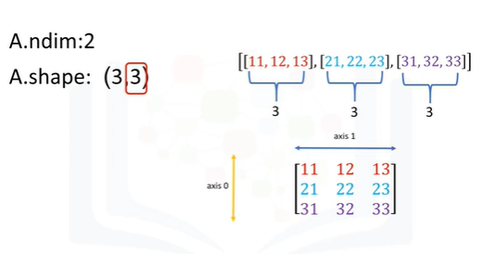

The convention is to label this axis 0 and this axis 1 as follows.

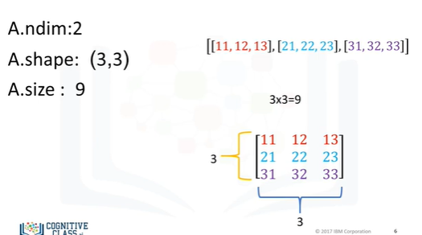

We can also use the attribute size to get the size of the array.

We see there are three rows and three columns.

Multiplying the number of columns and rows together we get the total number of elements, in this case 9.

Check out the labs for arrays of different shapes and other attributes.

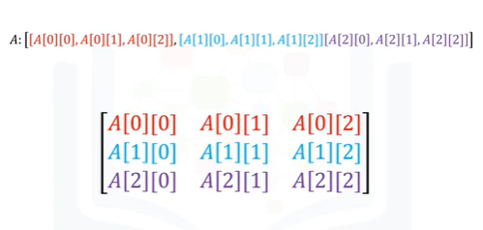

We can use rectangular brackets to access the different elements of the array.

The following image demonstrates the relationship between the indexing conventions for the list like representation.

The index in the first bracket corresponds to the different nested lists, each a different color.

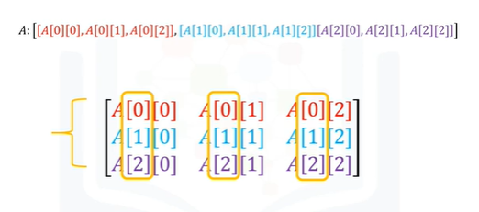

The second bracket corresponds to the index of a particular element within the nested list.

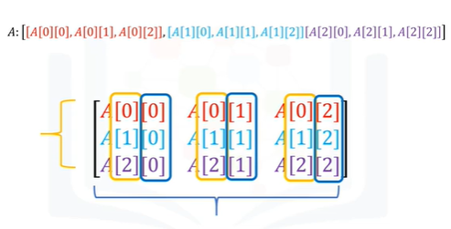

Using the rectangular representation, the first index corresponds to the row index.

The second index corresponds to the column index.

We can also use a single bracket to access the elements as follows.

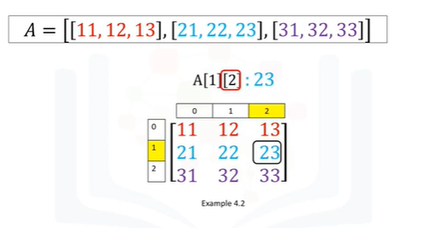

Consider the following syntax.

This index corresponds to the second row.

And this index, the third column.

The value is 23.

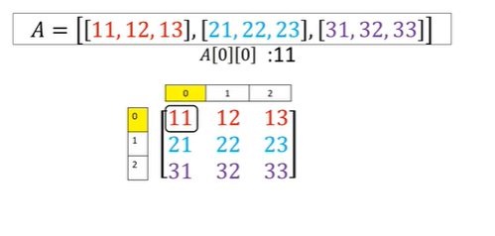

Consider this example.

This index corresponds to the first row.

And the second index corresponds to the first column, and a value of 11.

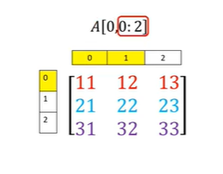

We can also use slicing in numpy arrays.

The first index corresponds to the first row.

The second index accesses the first two columns.

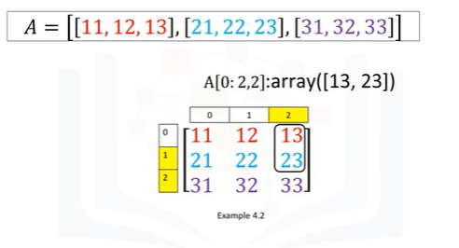

Consider this example.

The first index corresponds to the last two rows.

The second index accesses the last column.

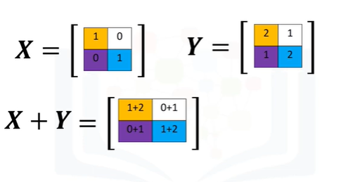

We can also add arrays, the process is identical to matrix addition.

Consider the matrix X, each element is coloured differently.

Consider the matrix Y, similarly each element is coloured differently.

We can add the matrices.

This corresponds to adding the elements in the same position i.e., adding elements contained in the same colour boxes together.

The result is a new matrix that is the same size as matrix Y or X.

Each element in this new matrix is the sum of the corresponding elements in X and Y.

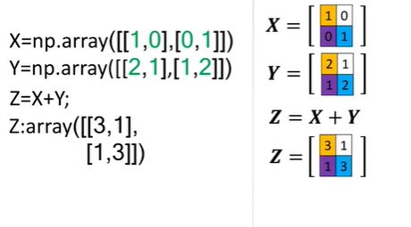

To add two arrays in numpy we define the array in this case X.

Then we define the second array Y.

We add the arrays.

The result is identical to matrix addition.

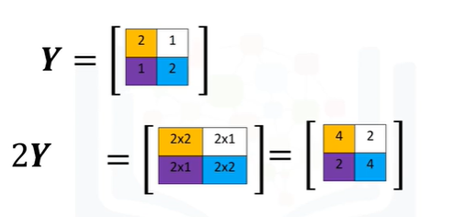

Multiplying a Numpy array by a scaler is identical to multiplying a matrix by a scaler.

Consider the matrix Y, if we multiply the matrix by the scaler 2 we simply multiply every element in the matrix by 2.

The result is a new matrix of the same size where each element is multiplied by two.

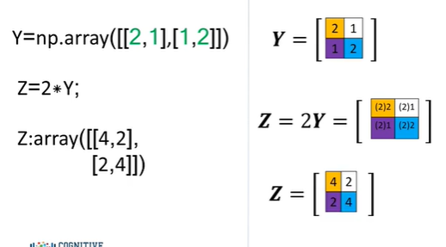

Consider the array y, we first define the array.

We multiply the array by a scaler as follows and assign it to the variable Z.

The result is a new array where each element is multiplied by two.

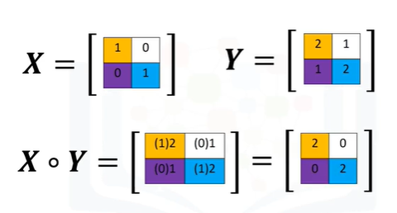

Multiplication of two arrays corresponds to an element-wise product or Hadamard product.

Consider array X and array Y.

Hadamard product corresponds to multiplying each of the elements in the same position i.e., multiplying elements contained in the same color boxes together.

The result is a new matrix that is the same size as matrix Y or X.

Each element in this new matrix is the product of the corresponding elements in X and Y.

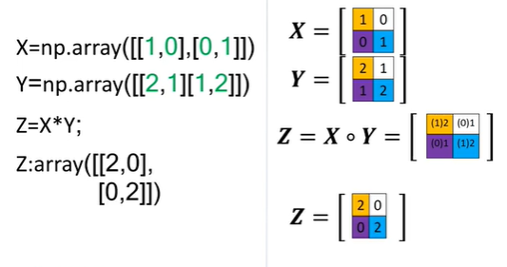

Consider the array X and Y.

We can find the products of two arrays X and Y in one line and assign it to the variable Z as follows.

The result is identical to Hadamard product.

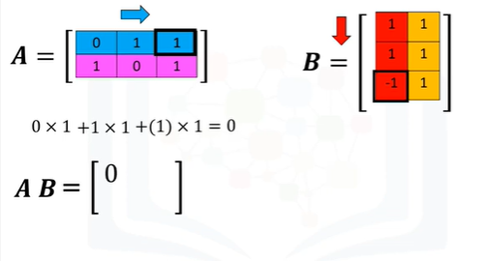

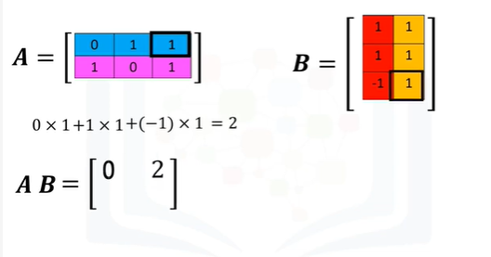

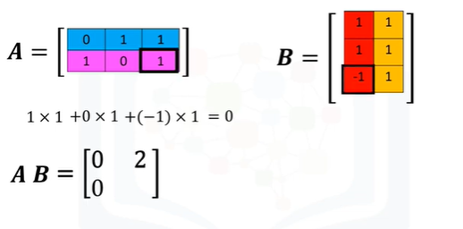

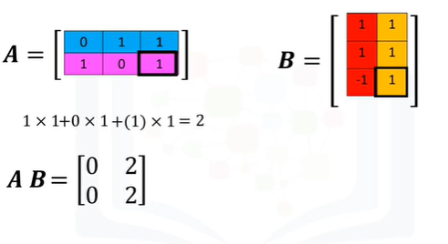

We can also perform matrix multiplication with numpy arrays.

Matrix multiplication is a little more complex, but let's provide a basic overview.

Consider the matrix "A", where each row is a different colour.

Also, consider the matrix "B", where each column is a different colour.

In linear algebra, before we can multiply matrix "A" by matrix "B" we must make sure that the number of columns in matrix "A", in this case 3, is equal to the number of rows in matrix "B", in this case 3.

For matrix multiplication to obtain the i-th row and j-th column of the new matrix we take the dot product of the i-throw of "A" with the j-th columns of "B".

For the 1st column 1st row, we take the dot product of the 1st row of "A" with the first column of "B" as follows.

The result is 0.

For the first row and the second column of the new matrix we take the dot product of the first row of the matrix "A" but this time we use the second column of matrix "B", the result is 2.

For the second row and the first column of the new matrix we take the dot product of the second row of the matrix "A" with the first column of matrix "B", the result is 0.

Finally, for the second row and the second column of the new matrix we take the dot product of the second row of the matrix "A" with the second column of matrix "B", the result is 2.

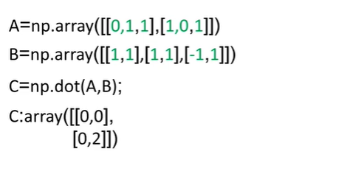

In numpy we can define the Numpy arrays "A" and "B".

We can perform matrix multiplication and assign it to array "C".

The result is the array "C".

It corresponds to the matrix multiplication of array "A" and "B".

There is a lot more you can do with it in numpy.

Check out numpy.org.

# Course Summary

Congratulation on reaching the end of this course. Well done!



By now you should be much more familiar with Python. But you won't really master these concepts unless you take the time to create some of your own Python programs.

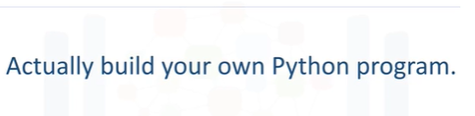

So feel free to use these videos as much as needed and reference Python documentation as you see fit at docs.python.org/3/

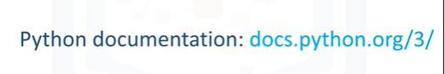

If you have questions, feel free to post them in the discussion forum for this course.



Finally, since you have come this far, we encourage you to take the graded review questions for each module, if you haven't done so already, as well as the final exam.

It's okay to find some of the questions difficult to answer.

Unlike the final exam, the review questions for each module are not time limited, so you can take the time to review the material before answering each question.

We hope you found the hands-on labs after each module worthwhile and that you’re now ready to use Python to create your own programs and applications, and that you’re motivated to learn more advanced topics in Python.

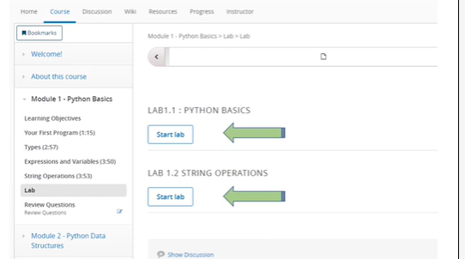

It has been a pleasure to introduce you to Python and we look forward to see you succeed in this endeavour.



Thanks for taking this course!

# Reference

1. Lutz, Mark. Learning Python: Powerful Object-Oriented Programming. " O'Reilly Media, Inc.", 2013.
2. Ana Bell, Eric Grimson and John Guttag.  [Introduction to Computer Science and Programming in Python](https://ocw.mit.edu/courses/electrical-engineering-and-computer-science/6-0001-introduction-to-computer-science-and-programming-in-python-fall-2016/), MIT Open Course Ware, MIT 2017